**Topic Proposal of the Course Paper**

Name: Zhou Renzhe SID: 181220076

School or Department:　school of Artificial Intelligence

**abstract**

Theoretical analysis shows that there are three important factors affecting the range of the solid ball when it is released, which are the height of the shot, the angle of the shot and the initial speed of the shot. In this paper, through simulation experiments and theoretical analysis, the effects of the shooting height, angle and initial velocity on the range of the real ball are studied respectively. Accordingly, this paper puts forward some simple suggestions for junior high school students to practice solid ball, so as to provide them with targeted training.

**Key words:** Solid ball, initial speed, height and angle of shot

**Introduction**

With the development of education, the goal of all-round development of morality, intelligence, physical fitness, beauty and labor is put forward. Throwing solid ball is listed as one of the sports examination items for the entrance examination of high school students. Most candidates think that with great strength, solid balls can be thrown far. It can be found in practice that this is not the case. So when the solid ball is shot, what factors are affecting the range of the solid ball?

**Main objective of the research**

**theoretical research:**

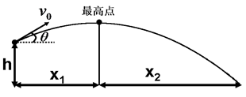(Figure1)

Figure1 is a schematic diagram of the motion principle of the solid ball after it is released, where x is the horizontal movement distance of the solid ball, V0 is the initial velocity of the solid ball when it is released, and theta is the angle of the release (or throwing angle), that is, the angle between the movement direction of the solid ball and the horizontal direction, and h is the height of the release. That is, the maximum height of the finger when the joints of the thrower's trunk and limbs are completely opened. g is the acceleration of gravity, and the value is ****.

**Formula deduction：**

From the kinematics principle, the expression of the horizontal motion distance S of solid sphere can be calculated. The calculation process is as follows:

Horizontal initial velocity of solid ball released is: 

Vertical initial speed of solid ball released is: 

The time when the solid ball hits the highest point is: 

So horizontal movement distance of solid ball in the first stage is: 

According to the equation: 

The time when the solid ball moves from the highest point to the ground can be obtained: 

So horizontal movement distance of solid ball in the second stage is: 

So horizontal movement distance of solid ball is : 

From the relations, we can see that there are three main factors affecting the size of range x, which are initial velocity V0, shooting height h and shooting angle theta.

In order to illustrate the influence of various factors on range, I use the Geometric Sketchpad to simulate the problem by controlling variables.

Nowadays, the starting height of junior high school students is basically between 1.8m and 2.5m, the starting speed is mainly between 4.5m/s and 11m/s, and the starting angle is 0 ~90.

Assuming that a student's starting height is h (h is between 1.8m and 2.5m), the initial starting speed is v (v is between 4.5m/s and 11m/s, note: h and V are fixed values), the angle of starting is changed, and the change of throwing distance is observed. The trajectory of the solid ball after throwing is shown dynamically with the geometric sketchpad. It is found that when theta is 0 the motion of the solid ball is a flat throwing motion and S is a non-zero value, which is recorded as S1; when theta increases, S increases; when theta increases to 40 degree, S reaches its maximum, which is recorded as S2; when theta continues to increase from 40 degree to 90 degree, S decreases gradually, it eventually becomes 0. Accordingly, I draw a curve of the throwing distance S varying with the angle of release, as shown in Figure 2.

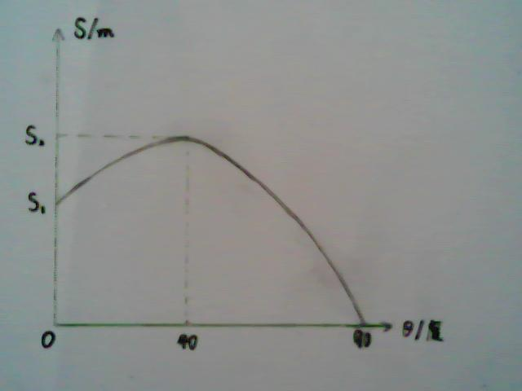Figure2 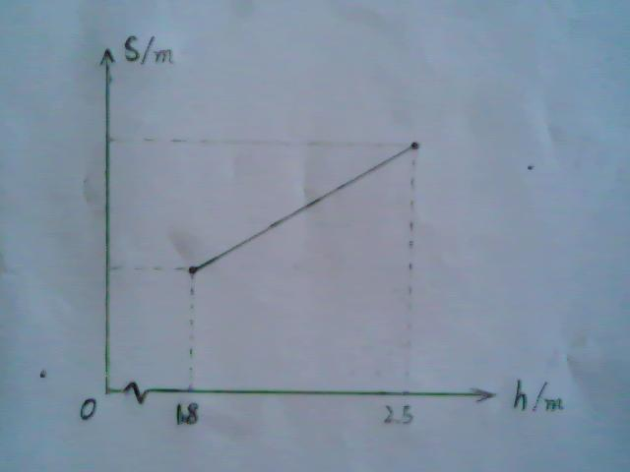Figure3

When the value of release height h is changed and the initial velocity V and angle theta of release are kept unchanged, the motion trajectory of solid ball is dynamically displayed on the geometric drawing board. It can be found that with the increase of release height, the throwing distance increases, and their relationship is shown in Figure 3.

As for the influence of the initial speed on the throwing distance, I can not carry out the experimental demonstration on the basis of the existing conditions and known knowledge, because I can not determine the initial speed of solid ball, but life experience shows that the initial speed of solid ball is mainly determined by the force of hands to solid ball. The greater the force the solid ball receives, the greater the initial speed, and the larger the throwing distance. (Note: The shooting height and angle remain unchanged at this time).

**Conclusion：**

Through the above experiments, I draw the following three conclusions.

1. The best throwing angle of junior high school students (i.e. keeping the throwing height, the initial speed unchanged, and the angle of the longest throwing distance) is about 40 degrees. When the angle is the best throwing angle, the throwing distance is the longest and the result is the best. 2. The throwing distance increases with the increase of the shooting height. The throwing distance is proportional to the shooting height.

3. The throwing distance increases with the increase of the initial speed of the shot, and the throwing distance is proportional to the initial speed of the shot.

**Summary：**

The above research shows that among the three factors affecting the range of solid ball, the shot height has the smallest influence, because the shot height is stable for each student and is not easy to change (human body will not change greatly in a short time). The throwing distance of solid ball has a maximum value with the change of the angle released. When the throwing angle is about 40 degrees, the throwing distance is the largest. Another main factor affecting the throwing distance of solid ball is the initial speed of the ball. The greater the initial speed, the farther the throwing distance is. The way to improve the initial speed is to strengthen strength training. The way to achieve the best throwing angle requires mastering the technical essentials and repeated guessing exercises, improving confidence and forming the correct movement stereotype.

**Reference:**

[1] Bao Yikuan, Influencing Factor Analysis and Technical Essentials of Solid Ball Throwing, Junior High School Mathematics Research Network, October 10, 2011.

[2] Liang Guojian, Analysis of the Factors Affecting the Distance and Nearness of Solid Ball Throwing, Mathematical Paper of the 23rd Guangdong Youth Science and Technology Innovation Competition, April 4, 2011.

[3] Baidu Library, Theoretical Analysis of the Far and Near Influencing Factors of Solid Ball Throwing, October 21, 2011.